**MIDDLE EAST TECHNICAL UNIVERSITY**

**DEPARTMENT OF ELECTRICAL & ELECTRONICS ENGINEERING**



**TROY TECH**

**WEEKLY REPORT #7**

**21.11.2018-27.11.2018**

**Section :** 7

**Studio Coordinator:** Mustafa Mert ANKARALI

**Partners :**

Hasan ÖZKARA - 2031888

Kağan ÖZASLAN - 2031854

Caner POTUR - 2031250

Mustafa Ercan OKATAN - 2031193

Mert KAYIŞ – 2030997

**Progresses for Previous Week:**

* We have gotten accumulator battery, 3 dc motors and wheels, we did some tests on them such as charging battery, driving motors.
* We have gotten three Arduino Uno, two motor driver L298n and PS1 joystick controller. Also, we collected many circuit components and get together.
* We are about to order another command control module until we will reach the shipped one(APC220) from banggod.com so that we will be able to do practical tests with nrf24l01 module in order to study on command control system.

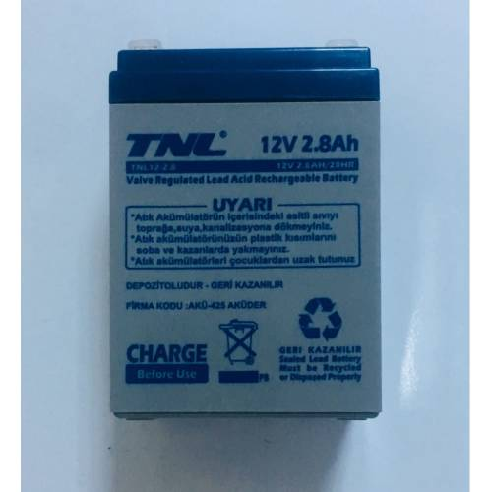

*Figure 1: TNL 12V 2.8Ah Battery*

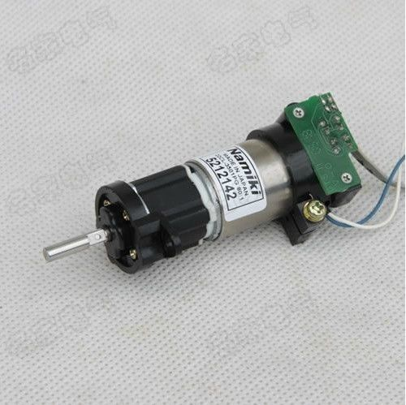

*Figure 2: Namiki 12V Coreless DC Gear Motor 22CL-3501PG 80:1 with Encoder*

**Plans for the Next Week:**

* Hopefully and finally, we are going to test FPV camera and receiver module after receiver module will be delivered to us.
* Doing tests on controlling joystick controller and process these command by Arduino.
* Doing tests on command control modules and try to send and receive data packages as wireless.